ACADEMIC CLOSED GROUP-DUPMC II MBBS GENEZENS PHARMACOLOGY ON FACEBOOK & CHANNEL –PHARMACOLOGY BY DUPMC INVICTUS ON YOU TUBE:
Academic closed group DUPMC SECOND MBBS GENEZENS PHARMACOLOGY was formed on Facebook .In these academic activity 145 students participated with different recorded video micro-seminars. This activity created e-book as resource in pharmacology for students.
Department of pharmacology has started Academic channel PHARMACOLOGY BY DUPMC INVICTUS on you tube. 135 students of Second year MBBS participated in micro- seminars with different titles of seminars. Seminars in video recordings generated academic recourse in Pharmacology. Attitude and communication of students improved through this activity. This activity created online learning resource for medical students.
While preparing video student were eager to know there language and content of seminar. This activity created unity, integrity and memories among the students of concern batches.
Information, knowledge and skills of the participant students explored through this e-book and you tube channel.
This activity was scheduled for students of second year MBBS, closed Facebook group named Genezens pharmacology with traditional (old) syllabus. You tube channel named as PHARMACOLOGY BY DUPMC INVICTUS was formed as per new competency based medical education (CBME) syllabus. Every student participating in seminar was allotted competency number and topic. Participant name is placed for their credit.
Pharmacology subject is made more interesting and understandable through multiple participation of students.
Upcoming medical students will use these online seminars for their understating in pharmacology.

HEALTH CARE CAMPS:
Dr. Ulhas Patil medical college and hospital arranges health care camps in urban and rural areas of Khandesh region. Physicians, surgens, residents, interns, nurses and paramedical staffs are visiting villages for health checkup. Those screened or diagnosed clinicaly are treated in health camps. Patients’ needs further diagnosis or tests for diagnosis are shifted to hospital. Hospital has all tertiary care facilities to treat diseases. All kind of hospital facilities like diagnosis, medical treatment or surgical treatment is provided to patients. Many health care camps are arranged by medicine and surgery departments in community. Health for all theme is operated by institute. During covid -19 pandemic institute contributed by providing covid 19 care hospital. All doctors, nursing and allied health care staff is participating in health care camps. Community is appreciating health care camps facility and efforts of dr ulhas patil medical college and hospital, jalgaon kh.
HUMAN MILK BANK-health benefits of breast milk are especially important for sick, weak and premature babies. The breast milk contains antibodies that fights against diseases and infections and even protects against allergies. Moreover, human breast milk even contains growth hormones that help the babies in their growth and development.
Breast milk bank offers families a chance of providing their children with healthy and reliable milk from other mother. This breast milk bank offers milk which is consumed mostly by babies whose mothers are unable to provide them with healthy or reliable milk.
Breast milk from breast milk bank is considered to be the “the next best” after the breast milk of the child’s biological mother. The donated breast milk is helpful in treating several conditions, such as mal-absorption, prematurity, short-gun syndrome, nephritic syndrome, intractable diarrhea, formula intolerance, some congenital anamolies, failure to thrive and immune deficiency.
Banked breast milk is useful for babies or infants who are in the neonatal intensive care units and also other babies at home requiring human breast milk. Breast milk donors are the healthy women who are concerened about the health of other babies and infants .Breast milk donors are usually lactating or nursing women who breastfeed their own infants and have got an abundant supply of breast milk and thus would donate their extra milk to the breast milk banks. These donors do not receive any compensation or payment for this generous act.
However there is an immense satisfaction that comes from knowing that their breast milk is used to feed needy babies. Dr ulhas patil medical college and hospital Jalgaon kh with rotary club of Jalgaon has set “Mata Amrut” Human milk collection center and human milk bank at Rajarshi shri shahu maharaj hospital jalgaon.
Dr.Ulhas Patil Medical College and Hospital Jalgaon Kh is having excellence and Distinctiveness in many areas but we have highlighted few of them.

Links for genezens pharmacology facebook group :
https://www.facebook.com/groups/744567336343736/?ref=share
link for INVICTUS PHARMACOLOGY YOU TUBE CHANNEL :
https://youtube.com/channel/UCZoNATbayaqt87vVeCtwI_g

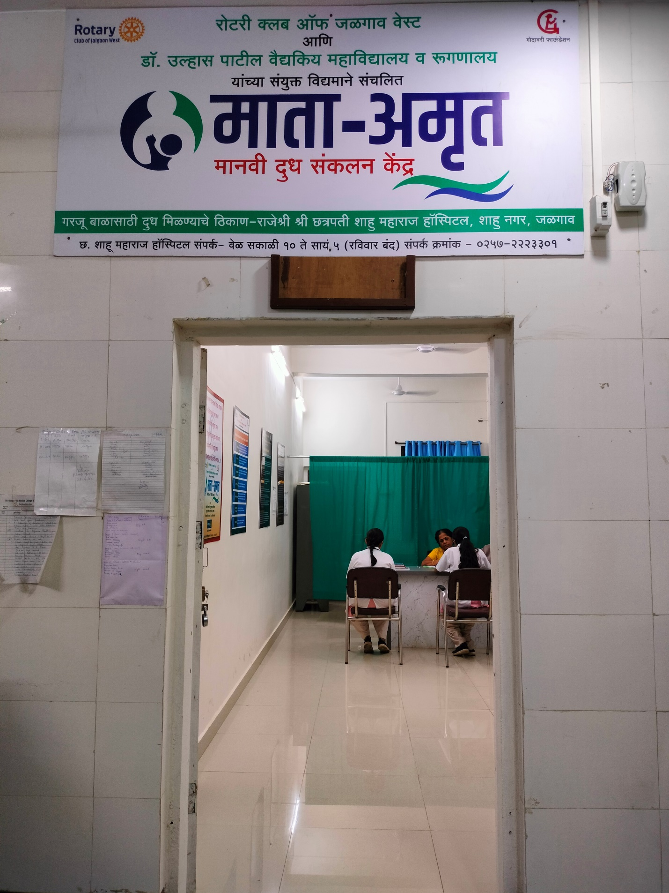
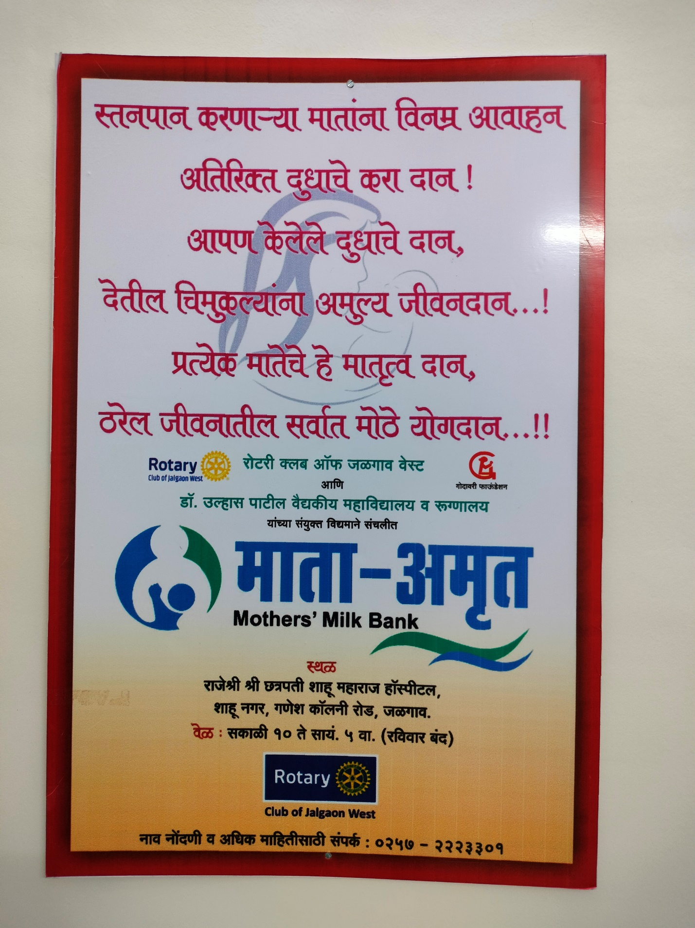
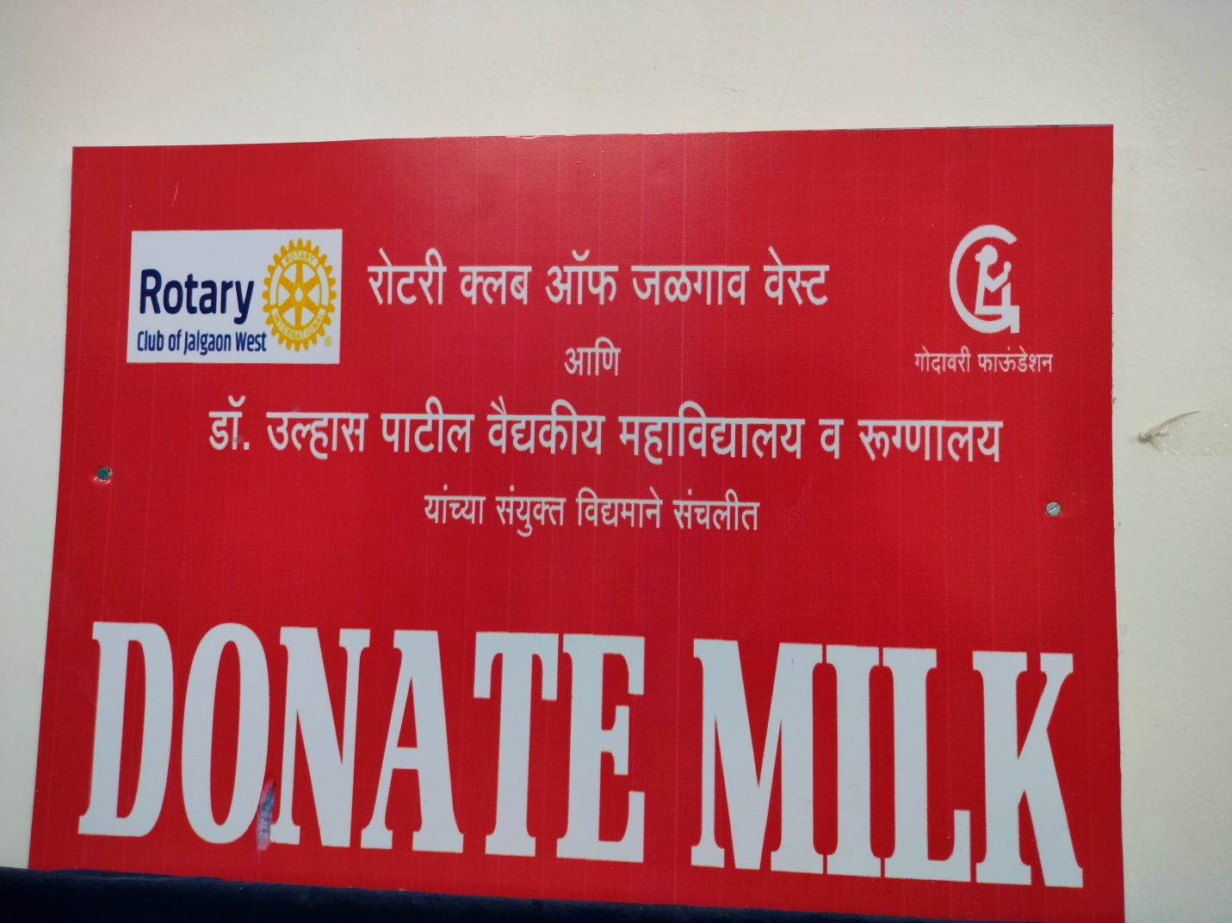

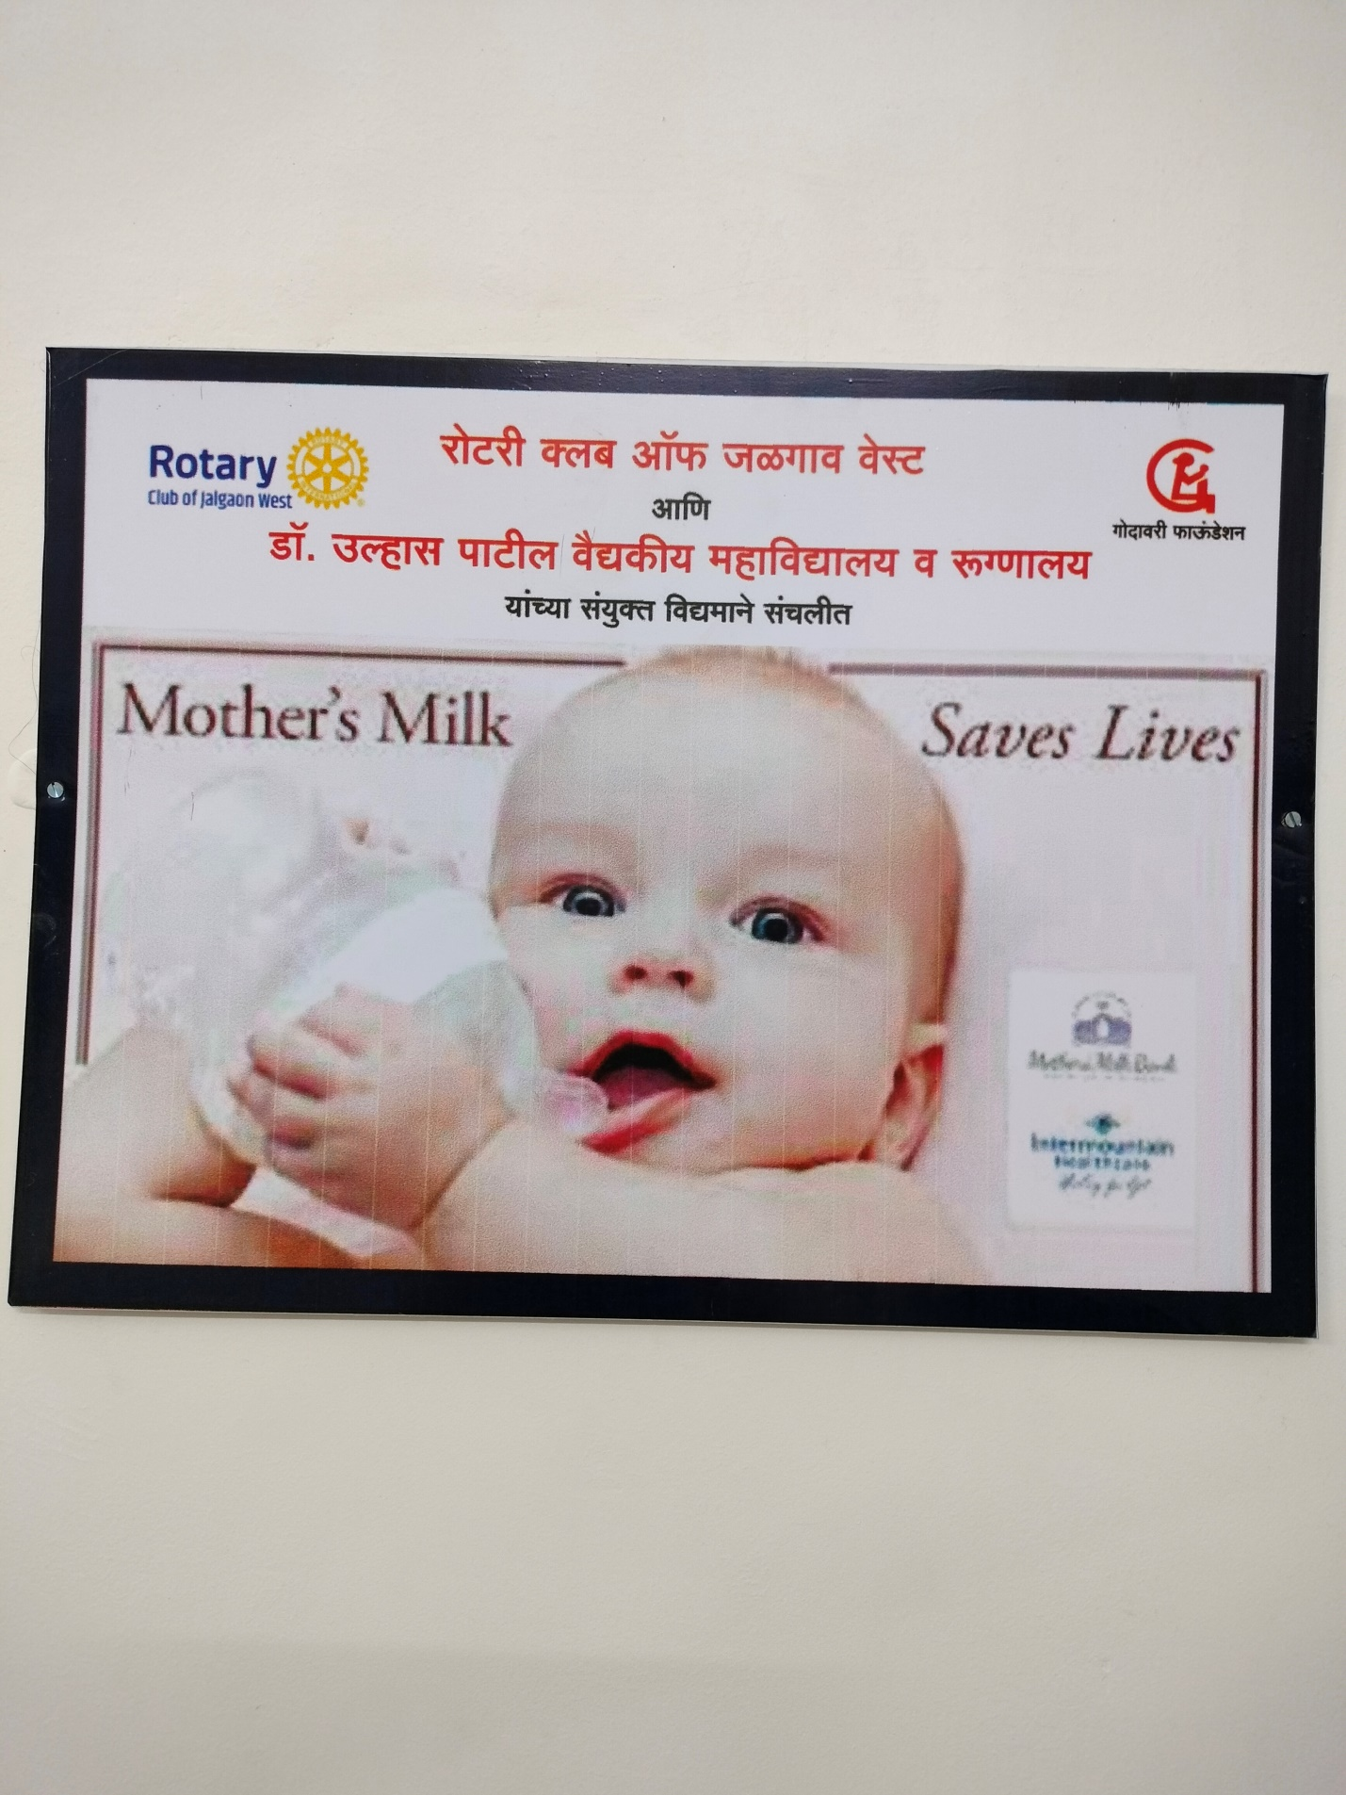

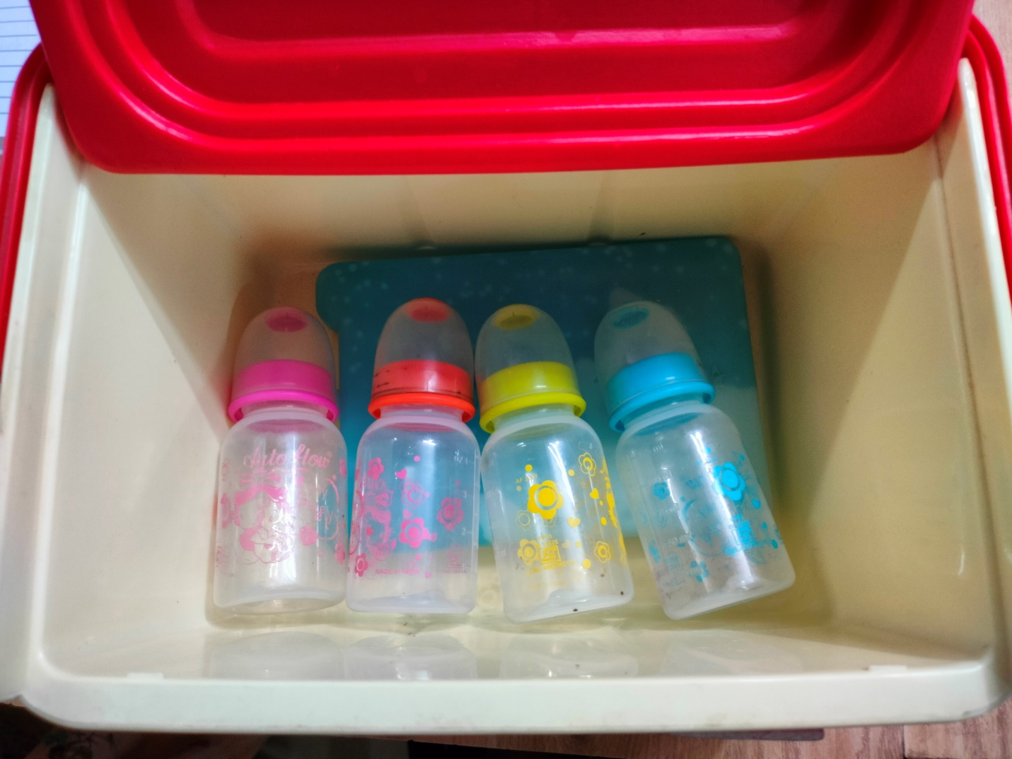
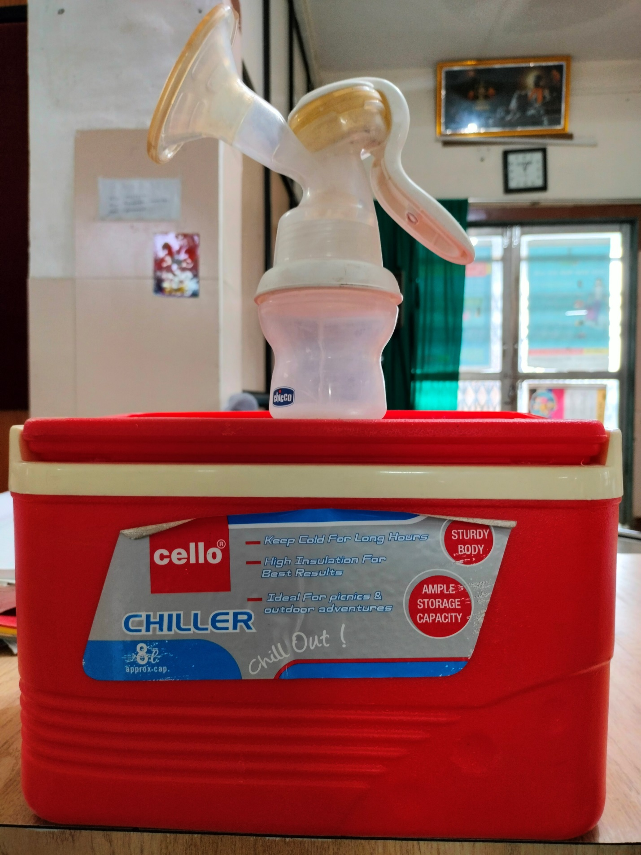
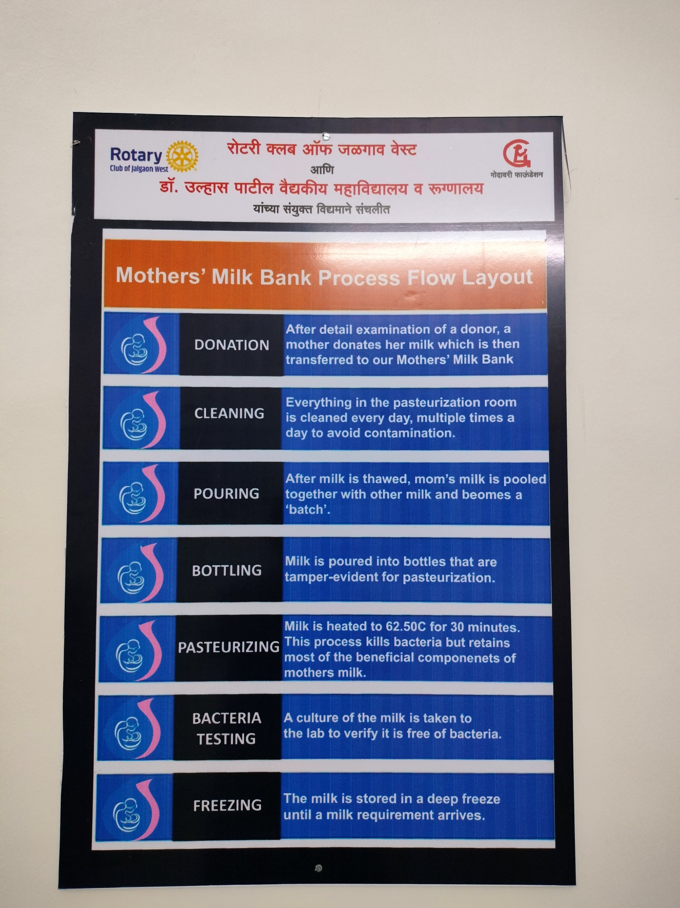
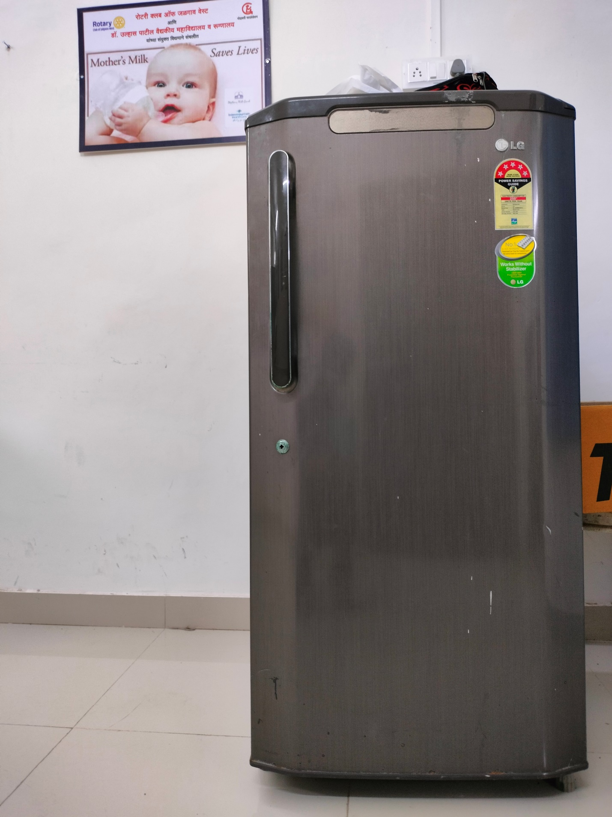
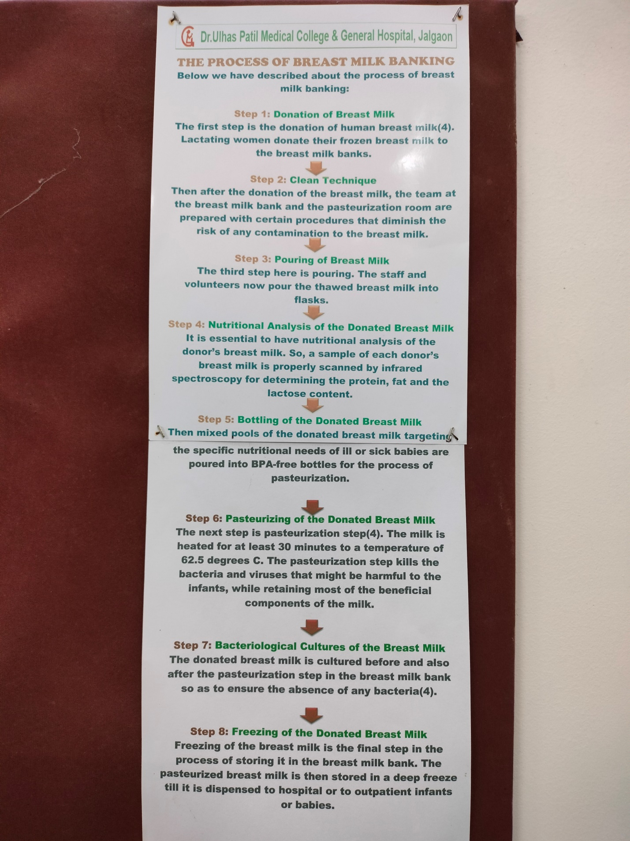
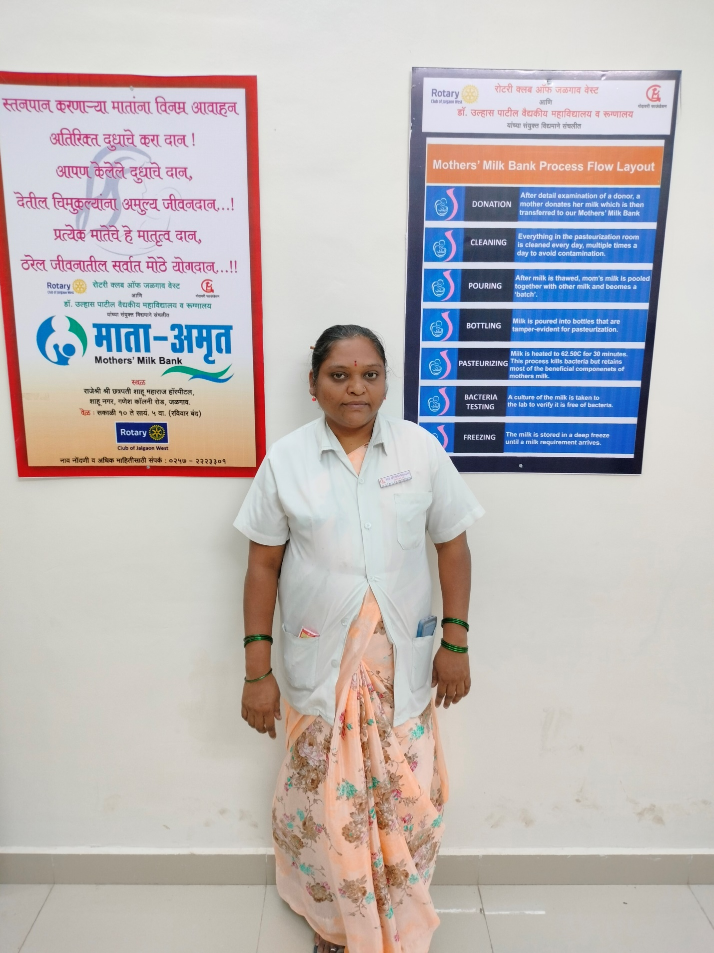

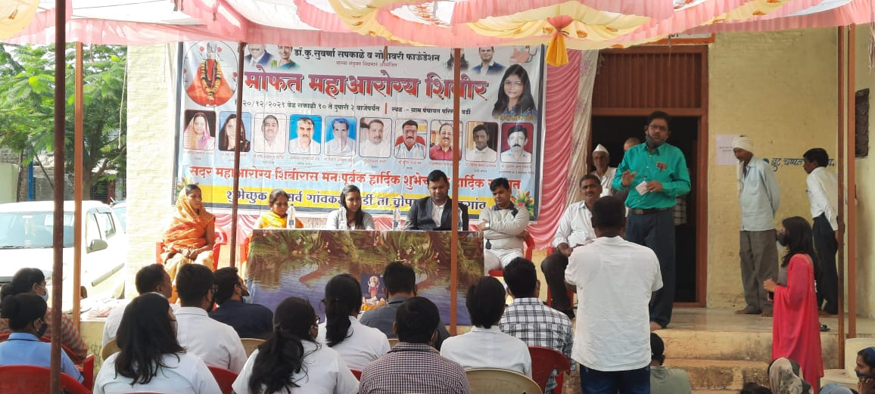
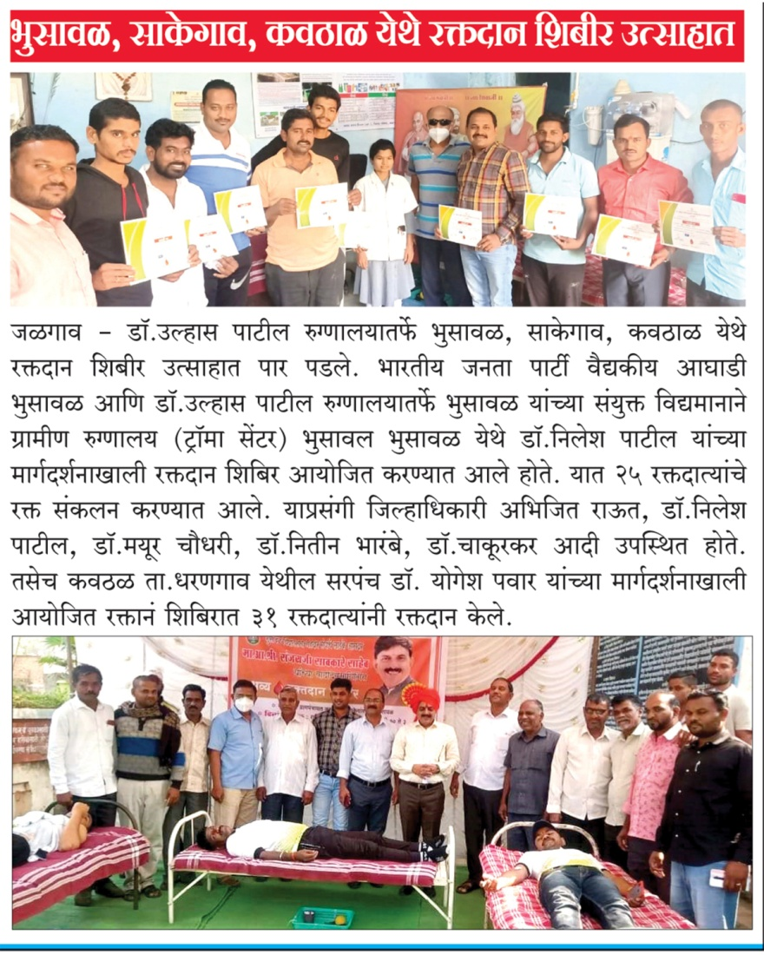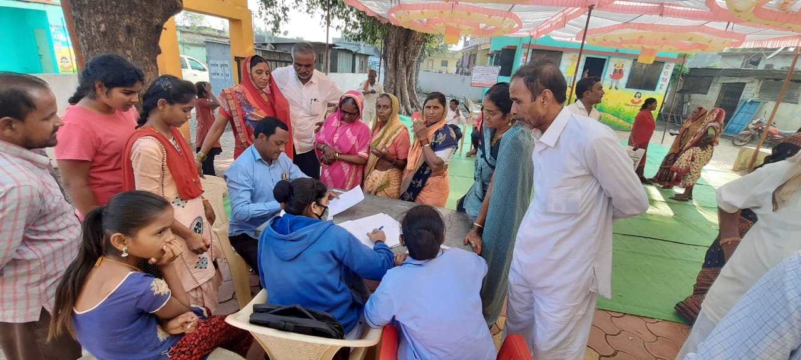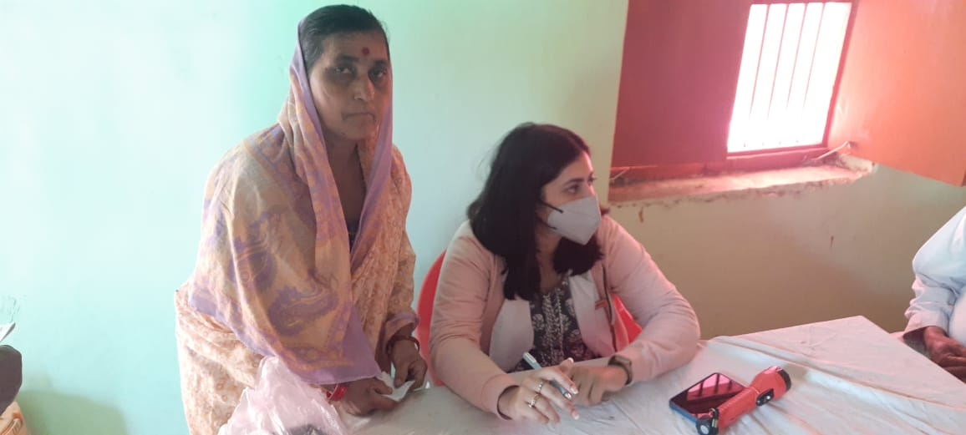
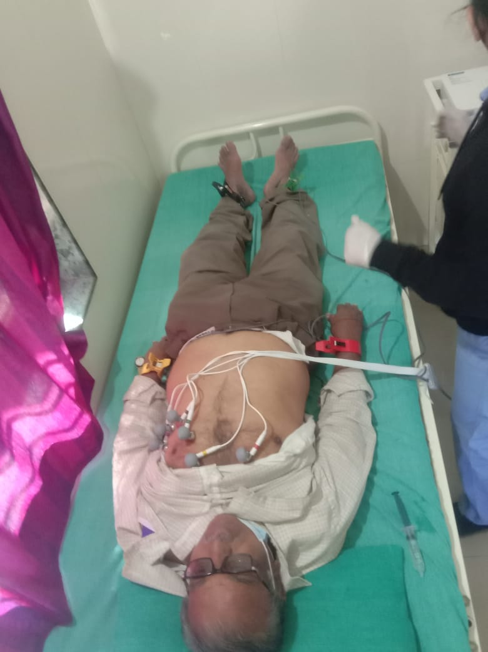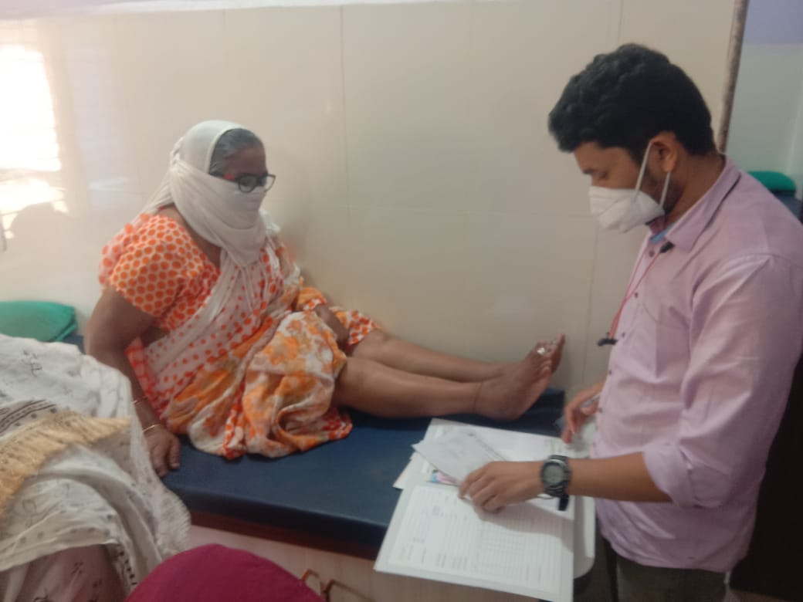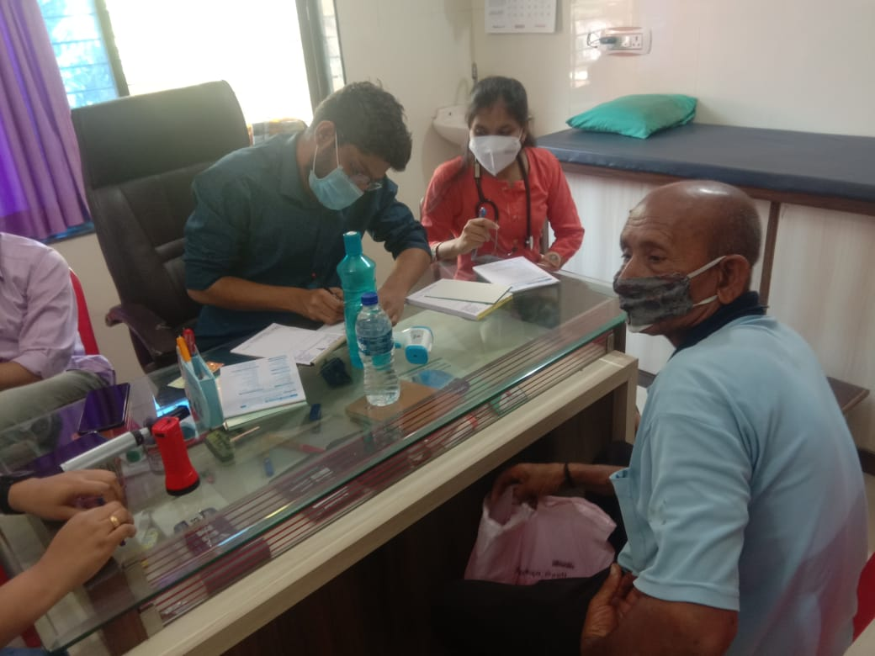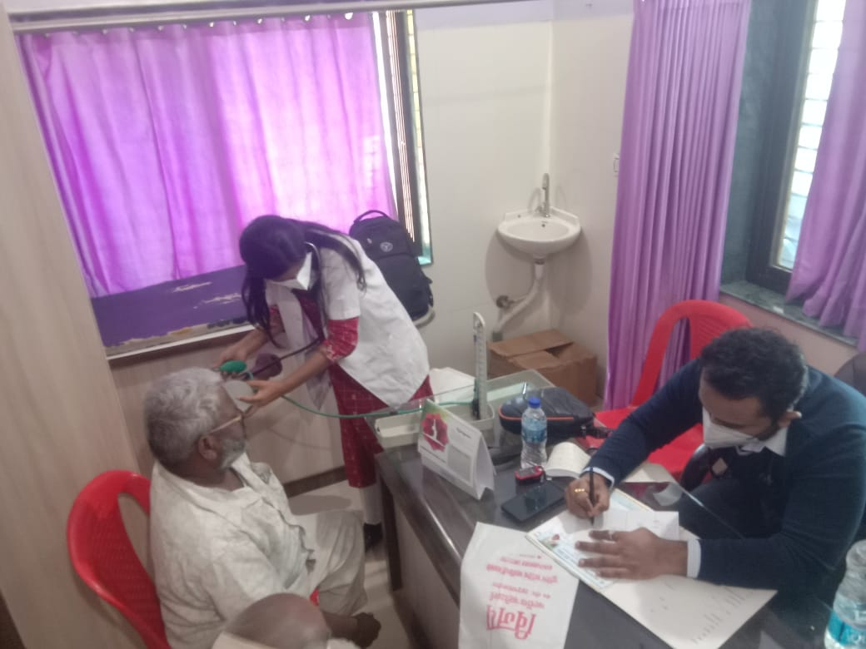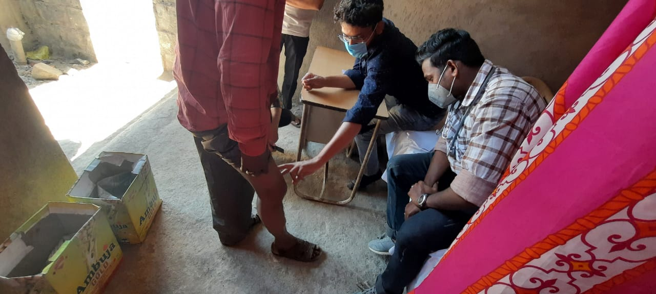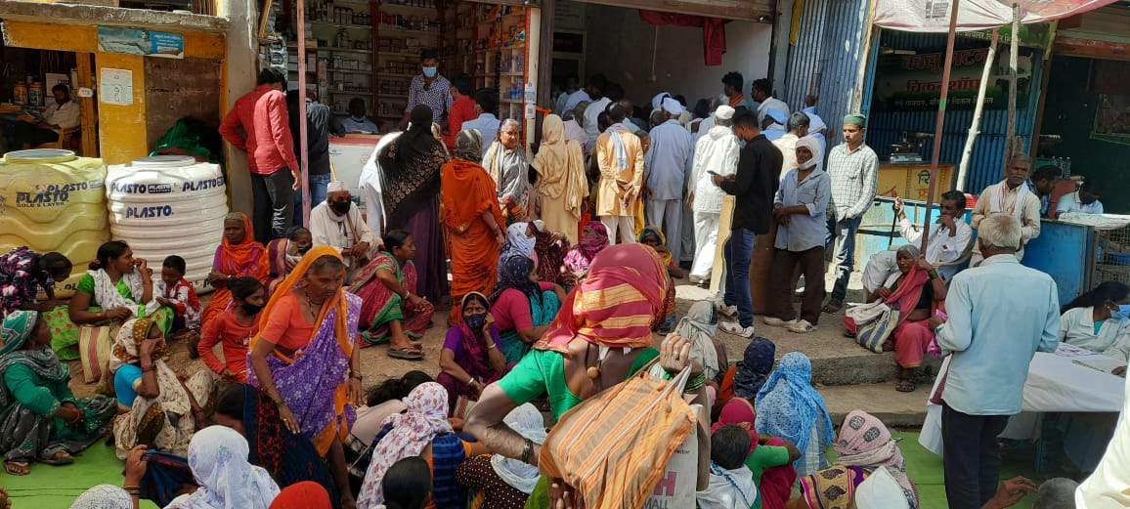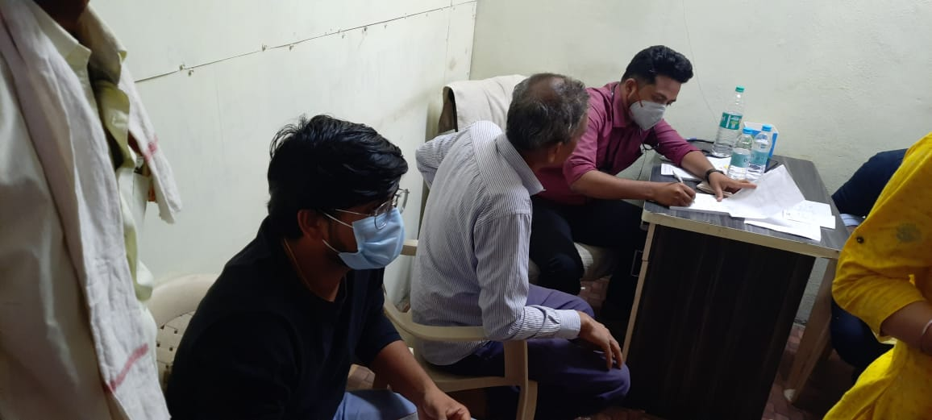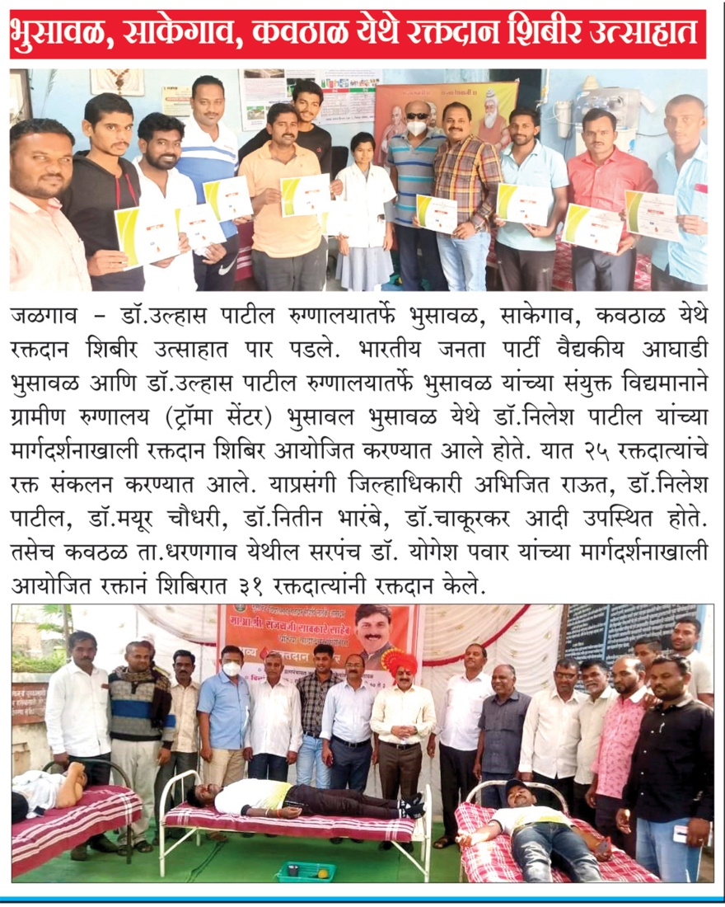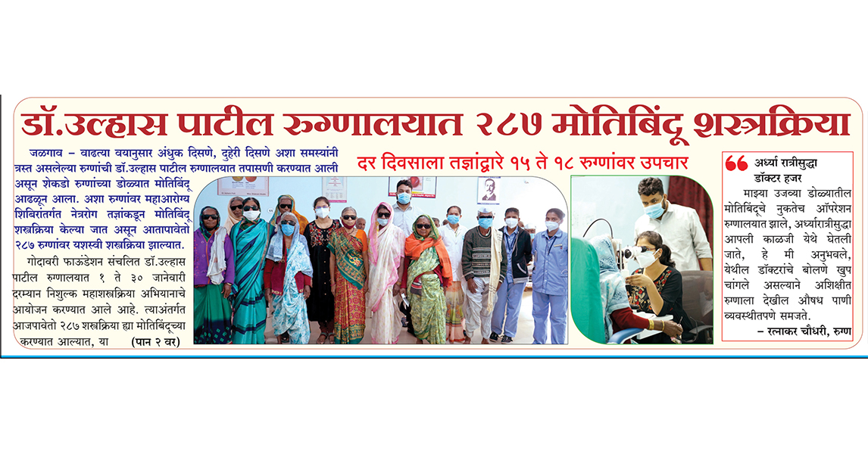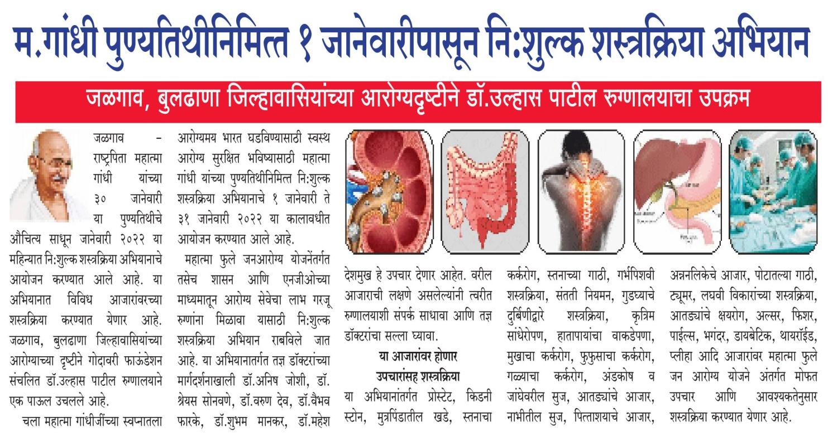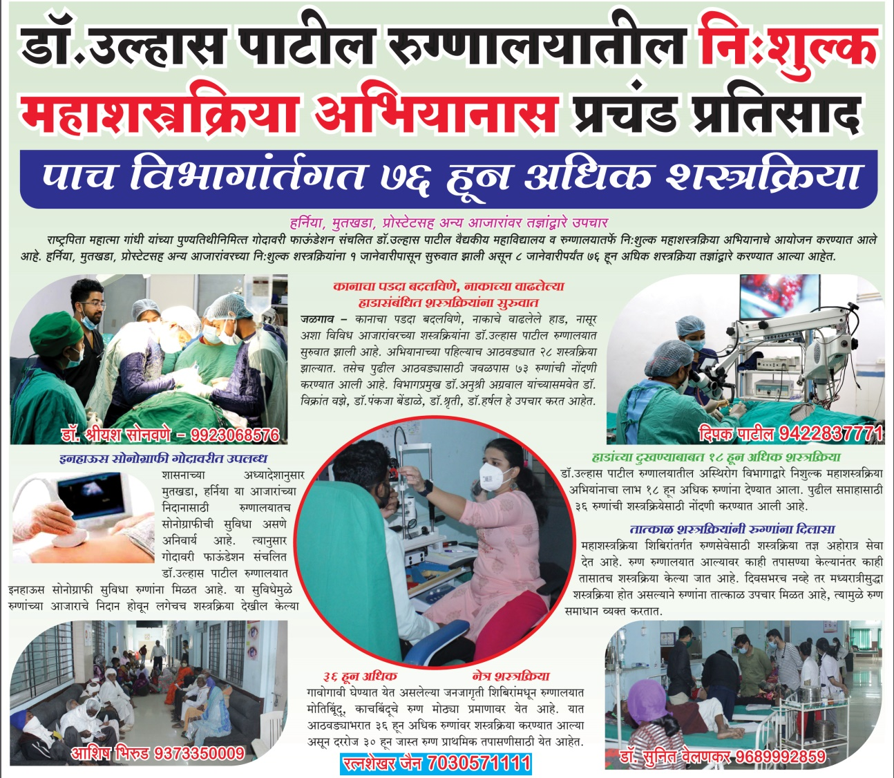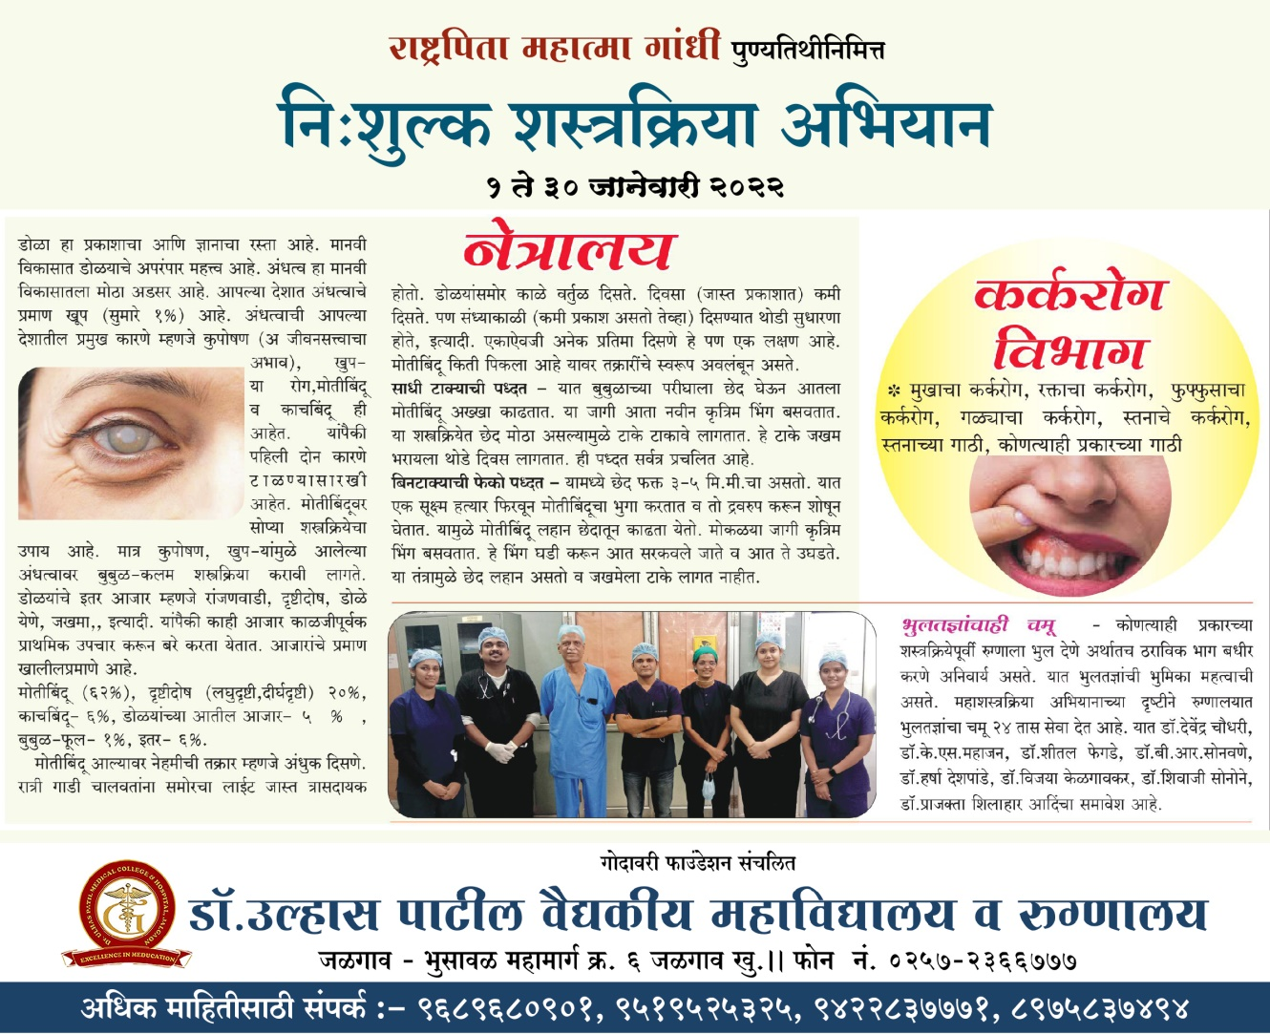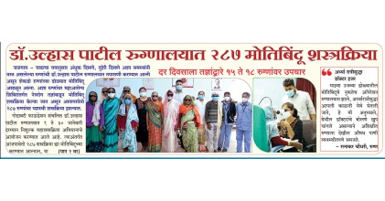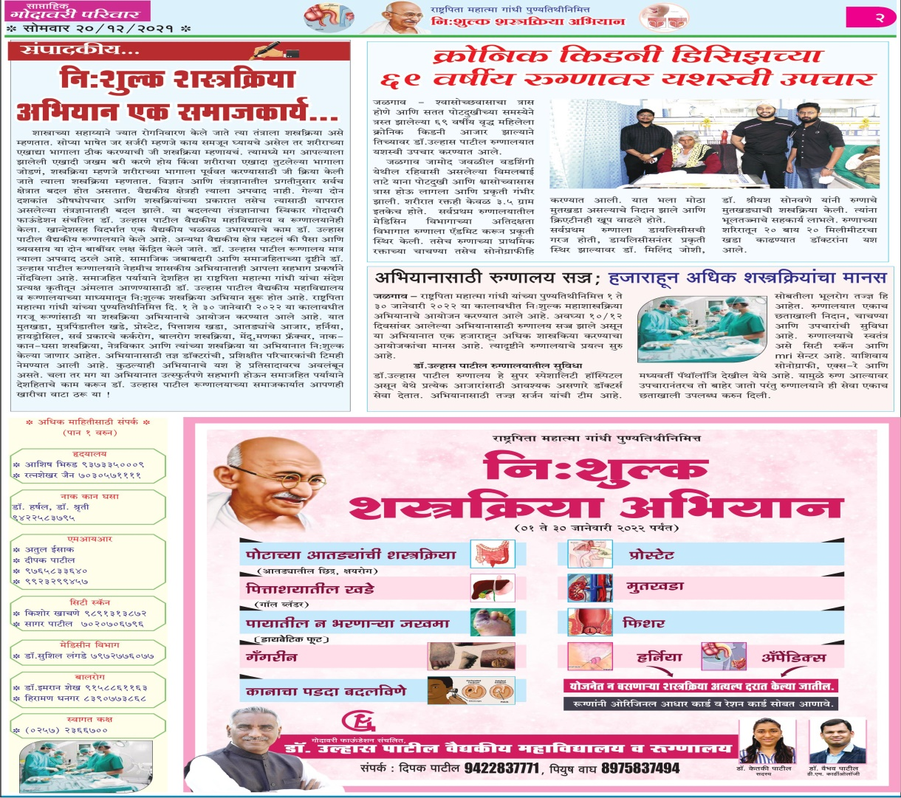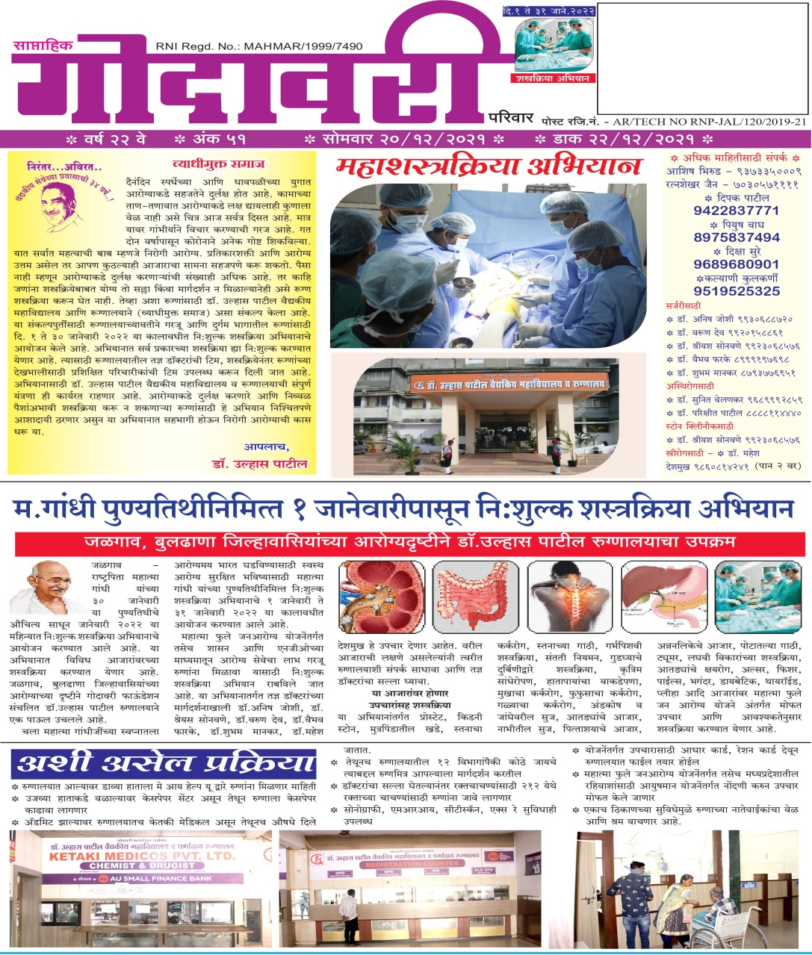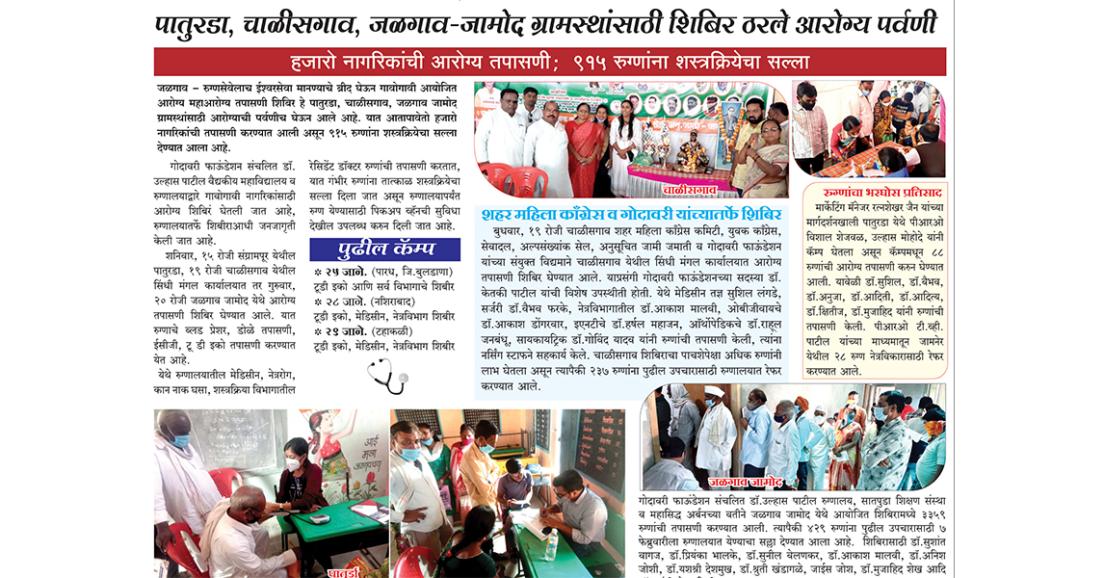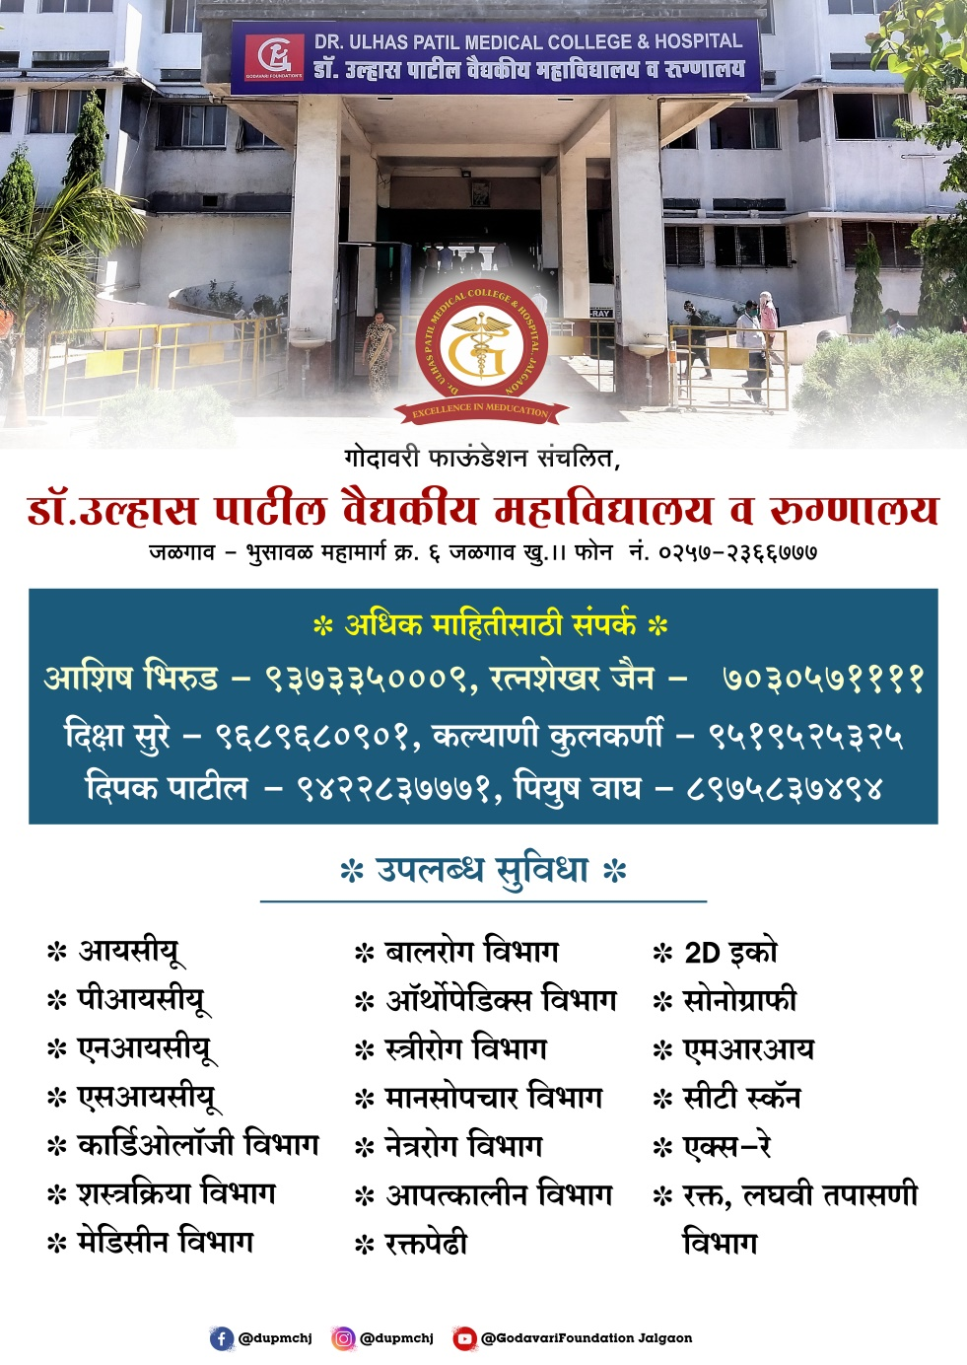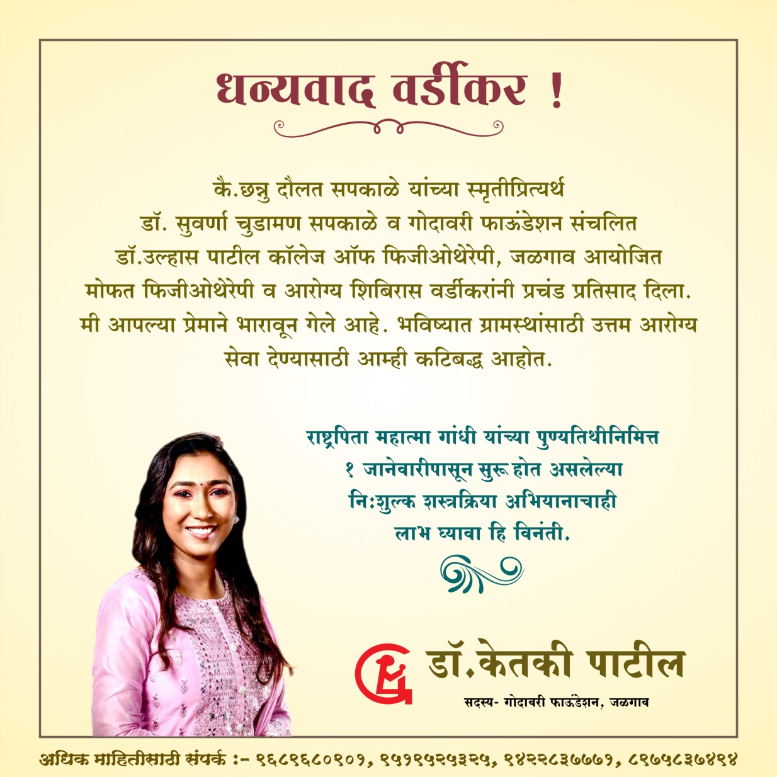

Invictus pharmacology you tube channel :

